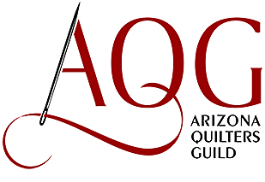

2023 Quilt Show: March 23 – 25, 2023
Mesa Convention Center
263 N Center St, Mesa, AZ

Preview Night: Thursday, March 23, 2023 5:00PM – 8:00 PM

Friday: March 24, 2023 9:00 AM – 5:00 PM

Saturday: March 25, 2023 9:00 AM – 4:00 PM

Admission Fees:

AQG Member (Must show AQG membership identification):

Thursday evening - $5.00
Friday or Saturday One Day Pass - $5.00

General Public:

Thursday Night - $5.00
Friday or Saturday One Day Pass - $10.00
or, $5.00 after 1:00 PM

Membership Special:

Sign up at the Quilt Show as a new AQG Member ($30) and receive 3 months free membership, then pay Member Admission Rates to enter the show. Children under 12: Free

