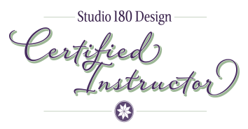
Joyce Holley
Noah & Her Sisters Quilt Co.
939 W Palma De Pina
Tucson, AZ 85704
816-223-4454 Quiltwithme2@comcast.net
Website: Noahsisterquilts.com
Facebook: Noah& Her Sisters Quilt Co.

Joyce is an energetic quilt instructor who truly delights in quilting and loves sharing this art form by teaching classes, leading retreats, sharing quilts at Guild trunk shows, lecturing and demonstrating new techniques. Her passion is for precision pieced quilts. Joyce expanded her passion in 2016 by becoming a Studio 180 Certified Quilt Instructor. Joyce’s quilting journey began in the early 80’s, making her first hand pieced and quilted quilt (well sort of). By putting her Home Ec. Vocational teaching experience into practice “In the Beginning” was born. This is a class truly for the person who has always wanted to make a quilt but did not know where to begin. “In the Beginning” began being taught in 1996 and continues being taught in various ways today.
With a hunger for learning and perfecting precision piecing techniques, Joyce continues practicing and leaning new point perfect precision techniques. Deb Tucker’s Studio 180 Tools and Rulers have been a great discovery. Joyce enjoys piecing and designing with the Studio 180 Tools. I would love to share the Joy of Quilting with you from the simple, to the intricate.

